Women of Color in the Academy
Allies Speakers
Below is the contact information of individuals (arranged alphabetically) who are recognized for their expertise in speaking on issues of gender and intersectionality of race, especially as related to women of color in the academy.
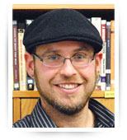
David Leonard, Ph.D.;
Associate Professor and Chair
Dept. of Critical Culture, Gender and Race Studies
Washington State University
E-mail: djl@wsu.edu
Phone: 509-335-6854
Website: http://libarts.wsu.edu/ccgrs/faculty/leonard.asp

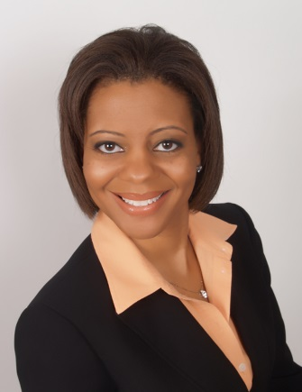
Kelly Mack, Ph.D.
Executive Director, Project Kaleidoscope
Association for American Colleges and Universities

Email: Mack@aacu.org
Phone: (315) 677-5267
Website: http://www.aacu.org/press_room/experts/mack.cfm

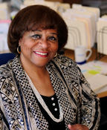
Yolanda Moses, Ph.D.
Professor
Special Assistant to the Chancellor for Excellence and Diversity
E-mail: yolanda.moses@ucr.edu
Phone: (951) 827-6223
Website: http://faculty.ucr.edu/~yolandam/

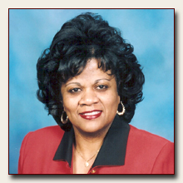
Christine Stanley, Ph.D.
Professor, Higher Education Administration
Vice President and Associate Provost for Diversity

Email: stanley@tamu.edu
Phone (979) 458-2905
Website: http://diversity.tamu.edu/AboutUs/stanleybio.aspx

